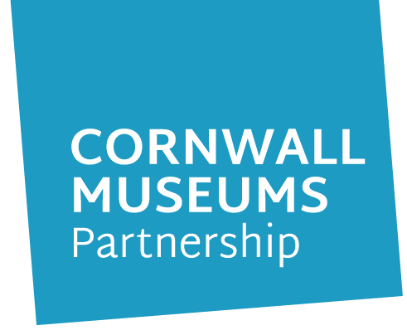
Cornwall Museums Partnership
APPLICATION FOR EMPLOYMENT

We are committed to equal opportunities in employment and service delivery,
and are only interested in your ability to do the job.

Please complete in clearly written or typed black ink, continuing on separate sheets where necessary.

1. PERSONAL DETAILS

First name/s: | Last name:
Title: | Contact telephone numbers:
Address: | Daytime:
 | Evening:
 | Mobile:
 | Email address:

2. EMPLOYMENT HISTORY - Present or most recent employment

Name of employer:
Job title: | Salary: £
Dates from / to
Period of notice / date available to start:
Key responsibilities:

Reason for seeking new position/leaving:

NB. If you have more than one employment please provide the same information for each job, if necessary on a separate sheet.

Name of employer:
Job title: | Salary:
Dates from / to:
Period of notice / date available to start:
Key responsibilities:

Reason for seeking new position/leaving:

3. PREVIOUS EMPLOYMENT

Please start with the most recent including any unpaid or voluntary work. Continue on separate sheet if necessary.

Job title and brief outline of duties | Name and address of employer | Dates  From - to  (month & year) | Reason for leaving

Please give details and an explanation for any gaps in your employment history:

4. EDUCATION, TRAINING AND DEVELOPMENT

Secondary school/college/university/apprenticeship including current studies, with the most recent first.

Name of institution | Full/part-time | Courses/subjects taken | Qualifications/grade
NB. We reserve the right to contact employers or educational establishments to verify details given.

Details of any relevant learning and development. Please include dates.
(e.g. short courses, first aid, computer skills, work-based NVQ etc., and any current courses.)

Professional / Technical membership
Name of professional / technical body | Grade of membership

5. SUPPORTING STATEMENT

Please read the job description and person specification. Using examples, show how your knowledge, skills and experience meet each of the essential requirements of the person specification and as many desirable
requirements as possible. Please draw on your relevant experiences; including paid employment, voluntary work, family experiences and leisure activities as evidence.

Please continue on a separate sheet if necessary.
6. ADDITIONAL INFORMATION

Do you hold a current full driving license?

Do you have access to a vehicle?

Do you have any endorsements?
If Yes, please state offence and date

Do you require a work permit?

Have you ever been convicted of an offence excluding those
‘spent convictions’ under the Rehabilitation of Offenders Act 1974
(If yes, attach details)
A Disclosure is only requested after a thorough risk assessment has indicated that one is both proportionate and relevant to the position concerned. For those positions where a Disclosure is required it will be requested in the event of the individual being offered the position.

Are you related to any Cornwall Museums Partnership employees?

Hobbies and interests

7. REFERENCES

Please give details of two referees, one of whom should be your most recent employer. If you are in, or have just completed full-time education, one referee should be from your school, college or university. Referees must not be related to you, or writing solely in the capacity of a friend, and must be able to comment on your skills and abilities in relation to the post.

References may be taken up before an interview or offer of employment, unless you request otherwise.

Name: | Name:
Address: | Address:
Tel no: | Tel no:
Email: | Email:
Occupation/Relationship: | Occupation/Relationship:
How long have they known you? | How long have they known you?

I agree to this reference being taken up before an interview I agree to this reference being taken up before an interview
or offer of employment being made: Yes/No or offer of employment being made: Yes/No

I declare that the information given in this application is, to the best of my knowledge, complete and accurate and that it may be used for purposes registered by the Council under the Data Protection Act. I understand that if, after appointment, any information is found to be inaccurate, this may lead to dismissal without notice.

Signature: | Date:
Where did you see the advertisement for this post?

CORNWALL MUSEUMS PARTNERSHIP

EQUAL OPPORTUNITIES
MONITORING FORM

Cornwall Museums Partnership operates an Equal Opportunities Policy. To help us monitor the effectiveness of our policy, you are requested to complete this form and to return it with your application.

This information will be separated from your application as soon as it is received. It will not be used in any part of our recruitment or appointment procedures.

PLEASE USE BLOCK CAPITALS

Name

Post applied for

Male

Female

Do you consider yourself to have a disability?
Yes |  |  |  | No
If you have answered yes please select the definition/s from the list below which best describes your impairment:

Learning disability/ difficulty |  | Long standing illness or health condition |  | Mental health condition |  | Physical impairment or mobility
Sensory impairment |  | Other |  | Please specify:
It would help us to know any barriers you have faced in dealing with us. Please also use this space to make suggestions on how we can improve.

How do you describe your ethnic origin?
Please read through carefully before selecting the ethnic group that you feel most closely reflects your background.

White
British |  | Cornish |  | Irish
Gypsy |  | Roma |  | Travellers of Irish Heritage

Other white background please specify:

Mixed
White & Asian |  | White & Black African |  | White & Black Caribbean

Mixed Cornish

Other mixed background please specify:

Black or Black British
African |  | Caribbean |  | Cornish

Other Black background please specify:

Asian
Bangladeshi |  | Chinese |  | Indian
Pakistani |  | Cornish

Other Asian background please specify:

SUBMIT YOUR APPLICATION

TO COMPLETE YOUR APPLICATION PLEASE SAVE THE APPLICATION AND THEN SEND AS AN ATTACHMENT TO emmie@cornwallmuseumspartnership.org.uk

OR POST TO

CORNWALL MUSEUMS PARTNERSHIP
STUDIO 116
KROWJI
WEST PARK
REDRUTH
CORNWALL
TR15 3AJ

