Directions to Krowji
Krowji
West Park
Redruth
TR15 3AJ
If you are coming from the A3047 bypass turn left before the roundabout.
If you are coming from Redruth town (Blowinghouse Hill) turn right before the roundabout up the one-way lane.
If you are coming from Illogan follow the road towards Redruth town (Blowinghouse Hill) and turn left up the one-way lane.

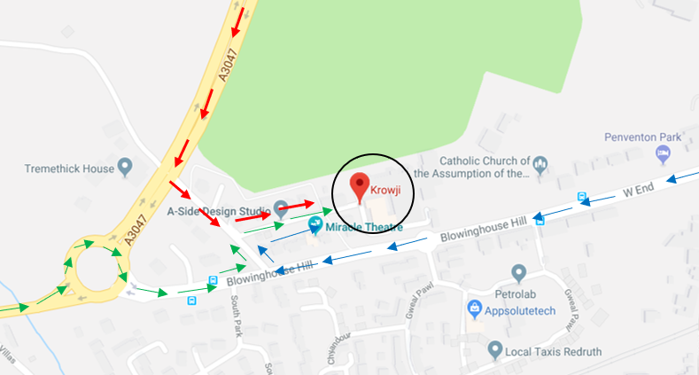

Is there parking at Krowji?
Yes, there is free any-time parking on site, however, the overflow car park at Krowji is currently closed due to construction work and parking is limited, please only park in marked spaces and do not park in hatched areas or by dropped kerbs. There are free on-road parking bays along Blowinghouse Hill and a Pay and Display car park at West End https://www.cornwall.gov.uk/transport-and-streets/parking/cornwall-council-car-parks/car-park-locations-charges-and-facilities/redruth/west-end-redruth-tr15-3ad/
Please don’t obstruct access for our neighbours to their houses and driveways.

Where is studio 106?
Studio 106 is based in the Percy Williams building the entrance is located in the open way on the right, there is a door entry system, press 106 enter for access, if there is no answer call Studio 101. Studio 106 is on the 1st floor just opposite the stairwell, there is lift access to all floors.

