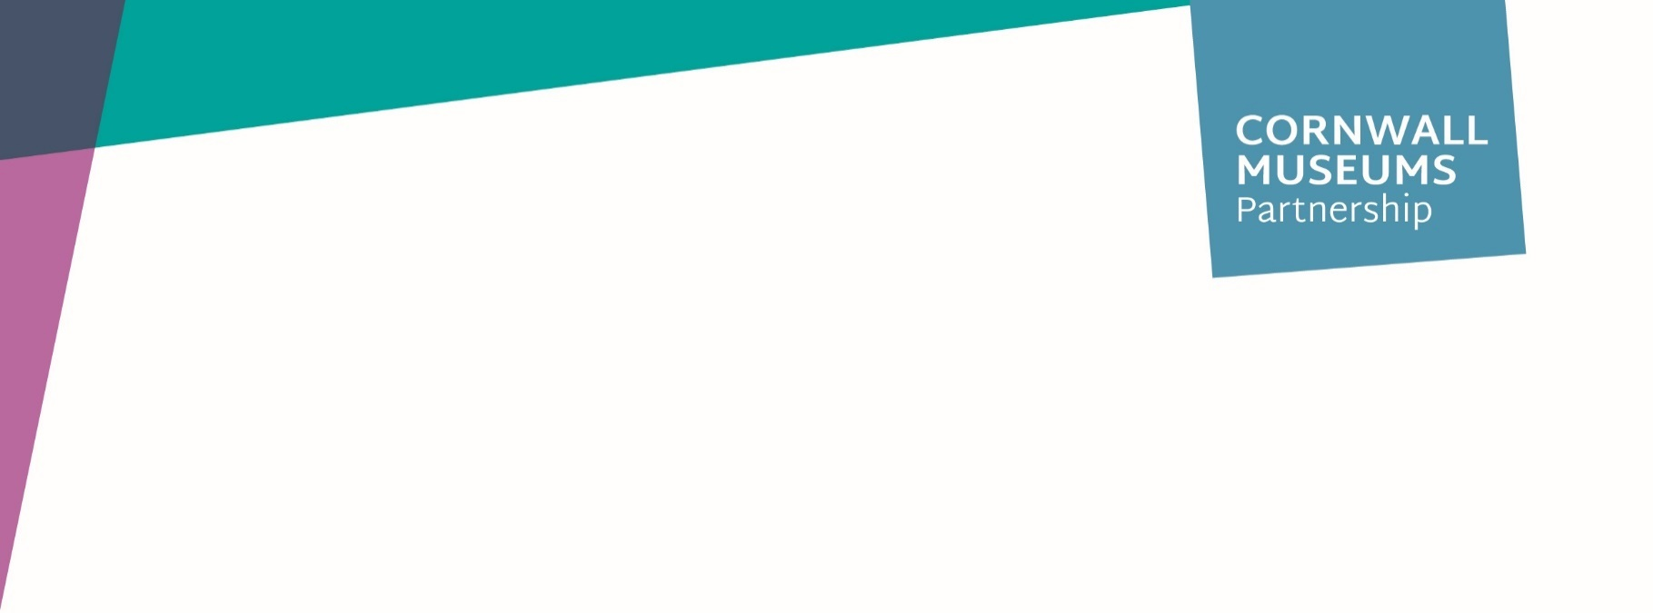
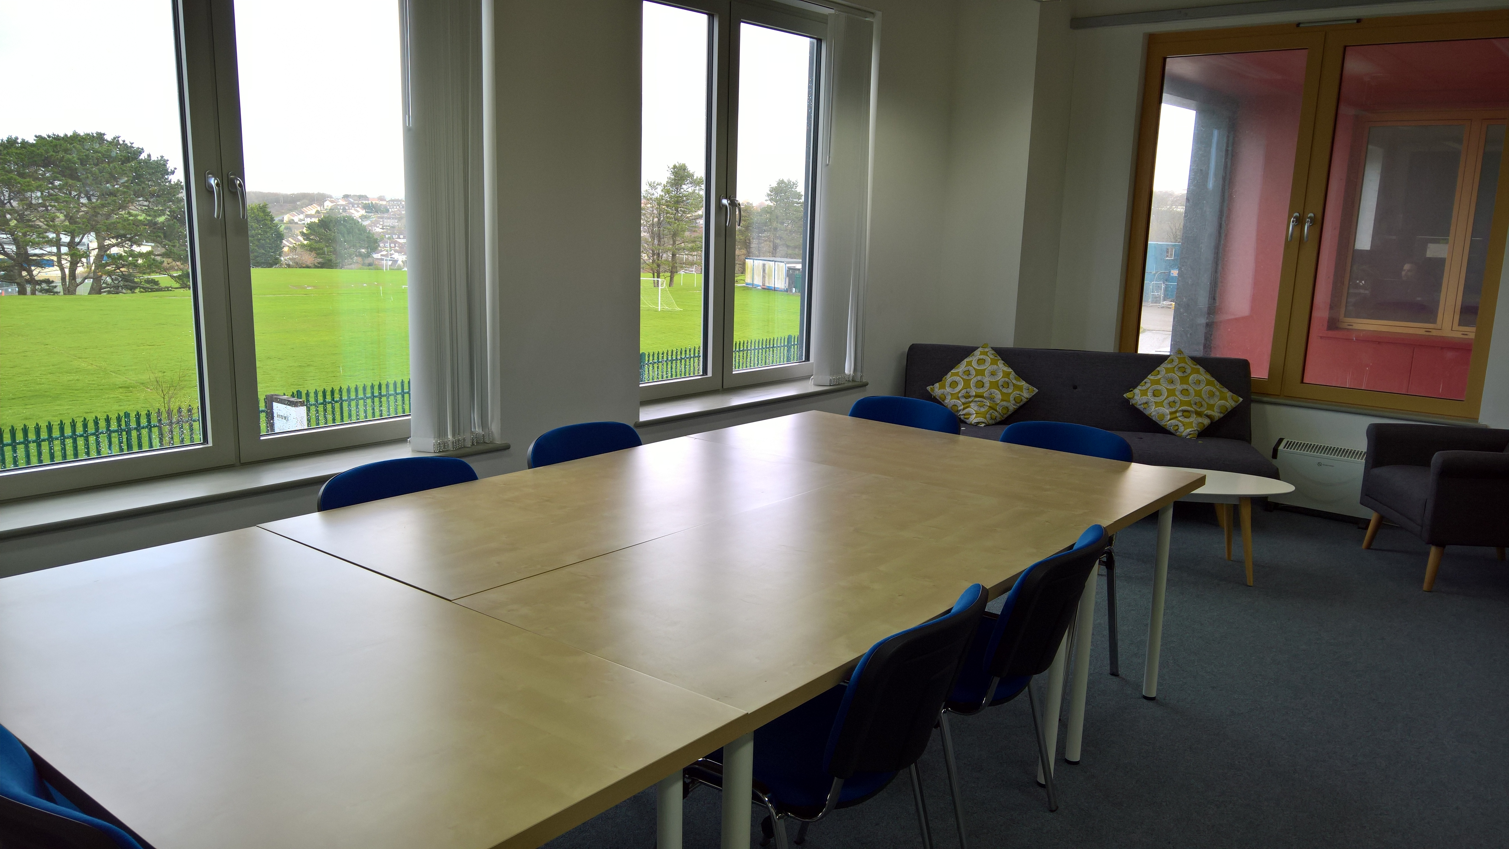
Studio 106 FAQ’s
For enquiries contact:
Karen Little
karen@cornwallmuseumspartnership.org.uk
Tel 01209 500 750

How much does it cost to hire?
Cornwall Museums Partnership charges £125 for a full day and £75 for half day with a 25% discount for NPOs.

Will there be any refreshments provided?
Tea, instant coffee, herbal teas and cow’s milk can be provided on a ‘make your own’ basis at a cost of £1.00 per person for each serving. Sandwich lunches can be arranged from £8.50/head with a minimum of one week’s notice. Equally you are welcome to provide your own refreshments or purchase from the Krowji café, but please note that Studio 106 must be left as you found it.

Can I see the space before &/or after I book?
We highly recommend that you view the space before booking, although you are welcome to visit at any time after booking. Please contact CMP to arrange this.

What times may I arrive/leave?
The meeting room will be open from 08:30 and closes at 17:00, please book enough time for your meeting. If your meeting over runs and there is a meeting following yours, you may be asked to leave or if you run beyond 17.00 there may be an additional cost to cover CMP staff time.

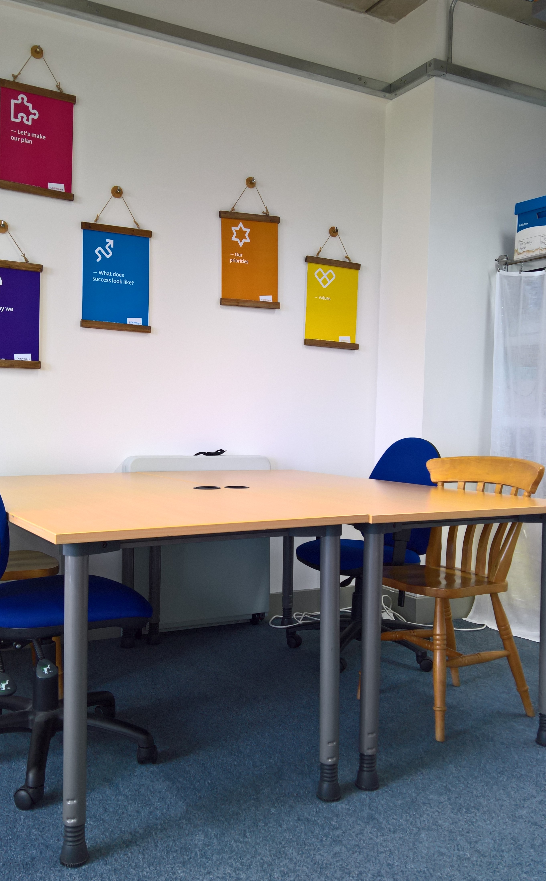
What is the maximum number of people the meeting room holds?
Studio 106 is approximately 42 m², has 12 chairs, 4 tables set boardroom style and a further 2 tables for break out. There is also a couch, armchair and coffee table. You are welcome to rearrange the tables and chairs but please return it to the original layout at the end of your meeting. Although there is no maximum number it is the responsibility of the person(s) booking the room to ensure it is suitable.

Does the room have AV/Wi-Fi?
Yes, it has a projector and a blank wall – please provide your own lap top to connect to it.
Studio 106 has password protected Wi-Fi. This is free to use with your meeting room booking – please ask if you would like to access the Wi-Fi and a password will be provided.
If you happen to encounter any technical issues whilst using the meeting room either call the partnership directly or pop down into our office down the corridor (Studio 101)
In addition, the room has a flip chart easel though an additional charge (£5/pad) will be made should you need paper.

What if I need to cancel/change my booking?
In the unfortunate event that you need to cancel a booking please see our terms and conditions of hire. If you need to make changes to your booking, please contact CMP as soon as possible and we will do our best to accommodate. Please note we can’t guarantee the dates you require.

