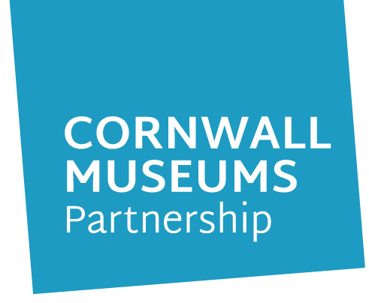
Who we are
Cornwall Museums Partnership is an independent charitable incorporated organisation, formed in 2015 to provide leadership for Cornwall’s museums; to support them, represent them and give them a voice. We are a sector-leading charity which is not afraid to think differently and respond to the museumscape around us, rather than wait for wisdom from “up the line.”
Our purpose is to help Cornwall’s museums to thrive so that they can share their collections to inspire, entertain, connect and inform. Our distinctiveness comes from our location; we are Cornish and rural. These are important characteristics and fuel our appetite to lead from the edge and act as a catalyst for new ideas and practice.
We are based in Krowji, Redruth.
Why Museums Matter
At their best, we think museums help us to explore some of the most fundamental questions about who we are and our place in the world. Museums help people look at the world through other people’s eyes. They can provide a space to develop new skills and boost confidence and provide a focal point for communities, bringing people together, promoting wellbeing and tackling loneliness.
Cornwall Museums Partnership exists to invigorate museums and inspire the wider cultural sector. We bring new ideas, new connections, new practice and new resources which we are keen to share and can be of benefit to a wide range of people and organisations.

Vision
We want to be recognised nationally and internationally as a pioneering model of collaborative leadership which promotes innovation and resilience in the museums' sector and beyond. We want to shift the dial in terms of the impact and value museums create. By working in partnership with museums we want to help them to use their collections to foster happy, healthy and prosperous communities where heritage is valued and celebrated.
Activities
There are three aspects to our services which will help us achieve our vision:
- Commissioning programmes in museums which help them to engage with more people and become more sustainable and resilient
- Brokering partnerships between museums and the private, public and voluntary sectors to help them access new skills, resources and markets
- Providing excellent training and support services which provide effective solutions to key challenges, question ‘business as usual’ and result in a skilled, networked, confident and happy museum workforce.

Values
Our values drive the way we work; they describe how we will make our vision real. We are:
- Collaborative: we believe that collaboration provides fertile ground for the flourishing of inventive and resourceful practice. We listen and form genuine partnerships which are built on mutual understanding and respect;
- Innovative: we seek new solutions and think differently. We pioneer new ways of doing things, and set high standards in everything we do;
And we are
- Inclusive: we respect and value multiple perspectives. We are committed to creating and maintaining an environment that respects diverse traditions, heritages, and experiences and is inclusive for everyone.

CMP is now used as a national exemplar for the cultural sector as a whole:
‘Within two years, the partnership – now 70-strong -is seen as a flagship project for rural areas throughout the UK.’ Department for Culture, Media and Sport
More information about our work can be found on our YouTube channel or in our latest Impact Report.

Board Member Role overview
As a board member of CMP, you will provide the strategic direction for the efficient delivery of the charity’s objectives working with over 70 museums, a range of community and business partners, Arts Council England, National Lottery Heritage Fund and Cornwall Council to maximise its impact.
You will be an ambassador for the charity supporting its ambitious agenda to help museums in Cornwall to thrive. We are seeking individuals with relevant expertise and experience to influence, shape and drive forward our mission.
To succeed, you will be a strategic thinker, with a passion for Cornwall, its museums, culture and future.
You will possess strong communication skills, with the ability to influence a broad range of high-level stakeholders.
The board meets 4 times per year and board members are expected to contribute an average of no less than 0.5 days per month of their time to the charity.
Although the board members are not remunerated, CMP funds travel expenses for trustees and supports professional development costs where appropriate, including an annual away day (usually outside Cornwall). The role includes opportunities to participate in national networks for the cultural sector.

Role Description for board members
Purpose
The role of board member is to ensure that CMP complies with all statutory and legal responsibilities, and that the charity is successful. Board members ensure that high standards of charitable governance are observed at all times. Board members are responsible for ensuring the overall strategic direction of CMP, and oversee the delivery of results by monitoring performance against agreed strategic objectives and targets.
Role description
General
- To act within the powers of CMP as set out in the company constitution
- To promote the success of CMP
- To exercise independent judgement
- To exercise reasonable care, skill and diligence
- To avoid conflicts of interest and declare where there may be conflict of interest
- To not accept benefits from third parties

Strategic leadership
- To ensure there is a clear vision and strategic direction and that the strategic objectives of CMP are in line with the objects defined in the company constitution and the agreed values
- To monitor progress towards achieving the agreed strategic objectives

Ensure effective governance
- To ensure policies and procedures reflect best practice and keep the organisation compliant with the law
- To ensure adherence to policies and procedures
- To ensure the sound financial standing of the company

Person specification
General
- Understanding of CMP’s operating environment and the key governance requirements for board members
- Experience at a strategic level in a third sector organisation or commercial business
- Enthusiasm for and interest in Cornwall’s heritage and culture

Strategic leadership
- Ability to analyse the environment, set and prioritise objectives
- Ability to make own views known and make decisions in a group environment and in line with strategic objectives

Communication
- Ability to listen intently, carefully and objectively
- Ability to convey ideas, information and opinions clearly and concisely

Team-working
- Supportive of the chair, fellow board members and the chief executive
- Ability to challenge the views of others appropriately
- Ability to build relationships with a wide range of stakeholders
Application process
If you are interested in joining our dynamic team to help create a bright future for Cornwall’s heritage please contact our Chair Fiona Morris for an informal discussion email fiona.morris@thespace.org
Applicants should submit a supporting letter outlining their skills and experience in relation to the role description and their reasons for being interested in the post, to Fiona no later than 5pm on 28th August 2020.

