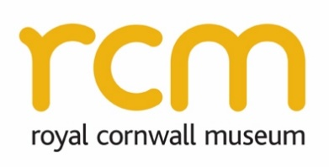
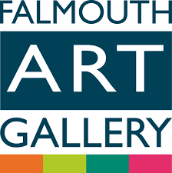
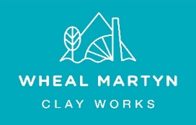
Trainee Curator

November 2020
.

Summary
Job Title: Trainee Curator (three posts)
Based at: Falmouth Art Gallery, Municipal Building, The Moor, Falmouth TR11 2RT
Royal Cornwall Museum, 25 River Street, Truro, Cornwall TR1 2SJ
Wheal Martyn Clay Works, Carthew, St. Austell, Cornwall, PL26 8XG
Salary: £17,000 plus pension, pro rata and essential travel allowance
(Pension and holiday allowance is specific to each organisation)
Hours: 37.5 per week (to include some weekends, evening and bank holidays)
Term: 9 months (11 January – 12 October 2021)

Role and Purpose
We are offering three exciting opportunities for individuals aspiring to develop a career in museums and galleries, as part of a wider programme led by Cornwall Museums Partnership. Our Trainee/Intern Curator roles offer a range of experiences aimed at developing the collections management and public engagement skills required of a 21st century curator. Each successful candidate will be employed by one of the three organisations above, where they will fulfil the majority of the role but also have the opportunity to work at all three locations during the contract, gaining experience in three very different regional heritage organisations.

The focus of the roles will be assisting with a range of collections projects including collections documentation, exhibitions, digital and community engagement as well as being involved in Museum Accreditation, as all three organisations work towards their periodic Accreditation assessments in 2021. Working alongside small and friendly teams of experienced museum professionals and volunteers the Trainee/Intern Curator will get to experience all aspects of museum work. This will include how to share the stories of our collections through displays and digital media and how to care for and manage these collections.

The Trainee Curator will be supported by an individual training plan and budget to allow them to attend training and undertake study trips to museums/galleries. Through Cornwall Museums Partnership they will benefit from, and contribute to, a peer network of other Curatorial Interns in Cornwall. These roles are entry-level positions designed to provide hands-on work experience in a range of museum activities. We welcome all backgrounds and are interested in the applicant’s potential to develop.

Key tasks
These positions will provide experience in a wide range of curatorial tasks, typical of those carried out by museum professionals in smaller, regional museums, including the following key tasks:

- Supporting museum staff and volunteers with collections management in line with Museum Accreditation standards, including collections care, practical conservation work and documentation tasks such as cataloguing objects and updating museum records
- Completing gallery inspections including environmental and pest monitoring
- Researching and developing exhibitions (both physical and digital) in line with the museum’s Audience Development Plan
- Assisting with preparing submissions for Museum Accreditation returns
- Sharing research and stories from collections digitally to provide greater access to collections
- Assisting the Engagement Officer and Education Officer with learning activities and events
- Creating content for the museum’s social media platforms and website
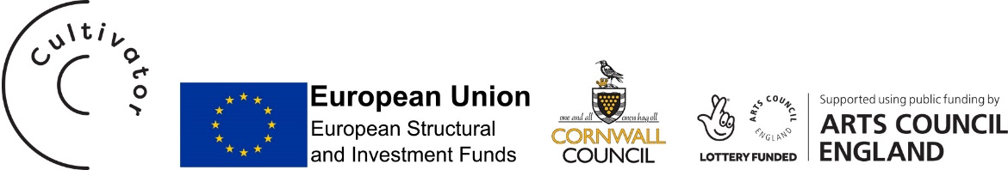
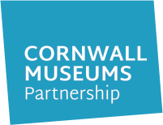

- Responding to research enquiries from the general public

- Hosting at least 1 Curatorial Intern peer network meeting and attending training and peer support networks led by Cornwall Museums Partnership
- Assist with the coordination and supervision of volunteers and Citizen Curators
- Maintaining records of work to inform funding reports and evaluation
- Taking responsibility for health and safety of yourself, colleagues, customers and contractors

The Trainee Curator will also have responsibility for developing a project based on their own career aims, to be agreed with the host organisation and potentially a collaborative exhibition/project involving all three.

Personal Specification
Qualifications
A Levels / Extended Level 3 Diploma / NVQ level 3 (or equivalent)
GCSE Maths and English at Grade C or 4 (or equivalent)
Experience & Knowledge
Enthusiasm and passion for culture, heritage and public engagement
Experience of volunteering or working with volunteers desirable
Research skills
Experience working with the general public desirable
Interest in industrial heritage / Art / cultural heritage
Skills & Ability
Excellent IT skills including use of Word, Excel and Social Media
Ability to multi-task with strong organisational skills
Self-starter with the ability to work independently
Team player
Commitment to learning and attending training
Good communication skills
Ability to build relationships with people of all ages, abilities and backgrounds
Flexible working and ability to adapt to changing situations

Application

Closing Date: 29 November (5pm) 2020

Interview: Week commencing 13 December 2020

Start Date: 11 January 2021

Apply: Email Ernie Shepherd (recruitment@wheal-martyn.com) with your CV and a covering letter explaining how you meet the Personal Specification, what interests you about the Trainee Curator opportunities and which organisation you would prefer to be based in and why. Please also complete the equal opportunities monitoring form at the following link:
www.surveymonkey.co.uk/r/TraineeCuratorsEqualOpportunitiesMonitoringForm

Context
These posts are funded with the support of Arts Council England through their National Portfolio Organisation (NPO) Programme, the John Ellerman Foundation and by the European Social Fund and Cornwall Council through Cultivator Cornwall. They are being delivered as part of a Cornwall Museums Partnership programme aimed at addressing the lack of curatorial skills and capacity in Cornwall’s museums. In doing so, they offer inspiring experiences for Trainee Curators and those seeking to work in museums, enabling them to gain skills, knowledge and experience working hands-on in museums.
